LOCKING IN SQL

-> it is used to when simultaneously two or more people doing the same task on the same db.

->oracle does shared locked until commit is performed

S X

S yes yes

X yes no

where(s=shared(read) , x=exculsive(write))

ROW LEVEL LOCK:

SITUATION:

Here USER2 is waiting for USER1 to commit, this is shared lock.

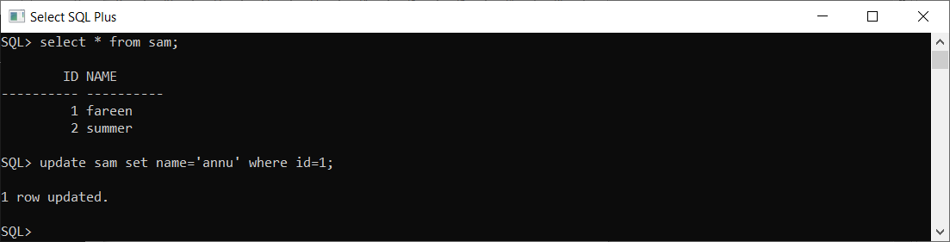USER1:(updated 1 row) USER2:(waiting for user1 to commit)

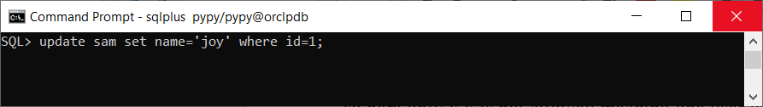

Here USER1 commited so the USER2 row is updated.

USER1:(commited) USER2:(user2 row updated after USER1 commit)

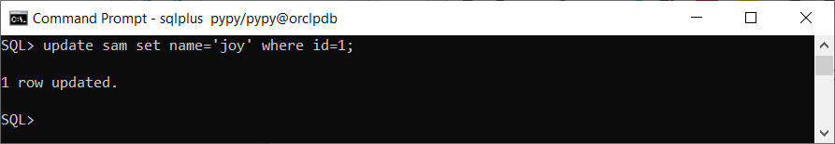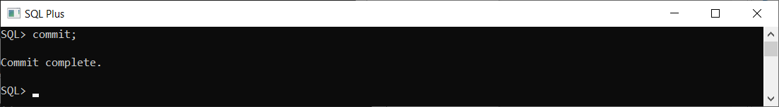

DEADLOCK IN ROW LEVEL LOCK:

Here USER1 is updated one record , and USER2 update the record and waiting for user one to commit.

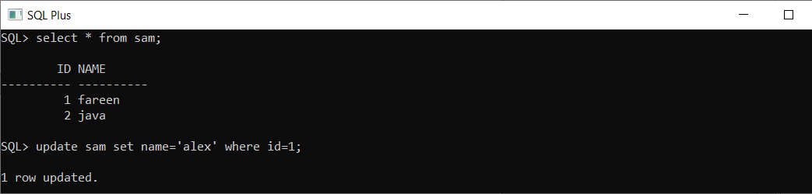USER1 USER2



Here USER2 is waiting for USER1 commit , at the same time USER1 updated one more record and waiting for USER2 to commit, while USER2 is waiting for USER1 to commit, in this case both user end up waiting.

UESR1 USER2

